18). Create a SQL storage service and perform a basic query using any Public Cloud Service Provider (Azure/GCP/AWS) to demonstrate Database as a Service (DaaS).

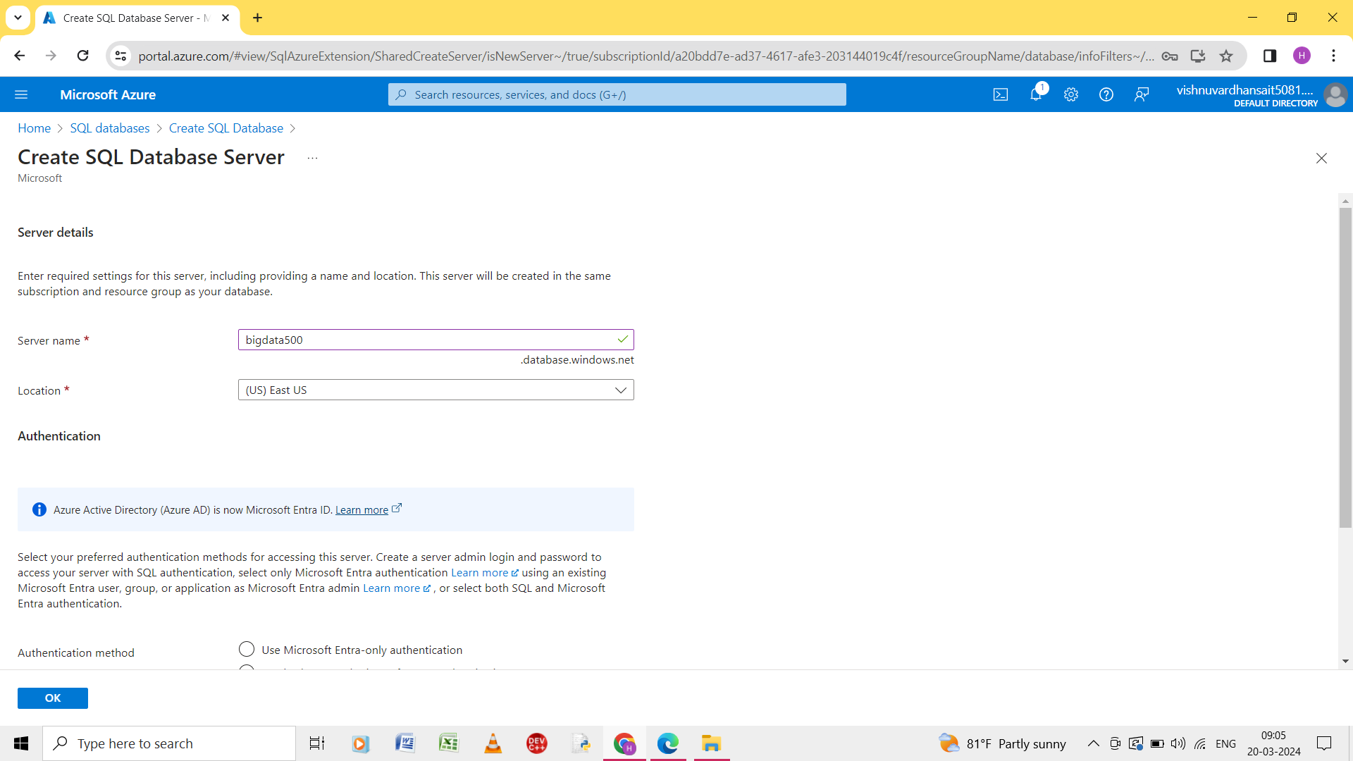

Step 1: give the name of the server.

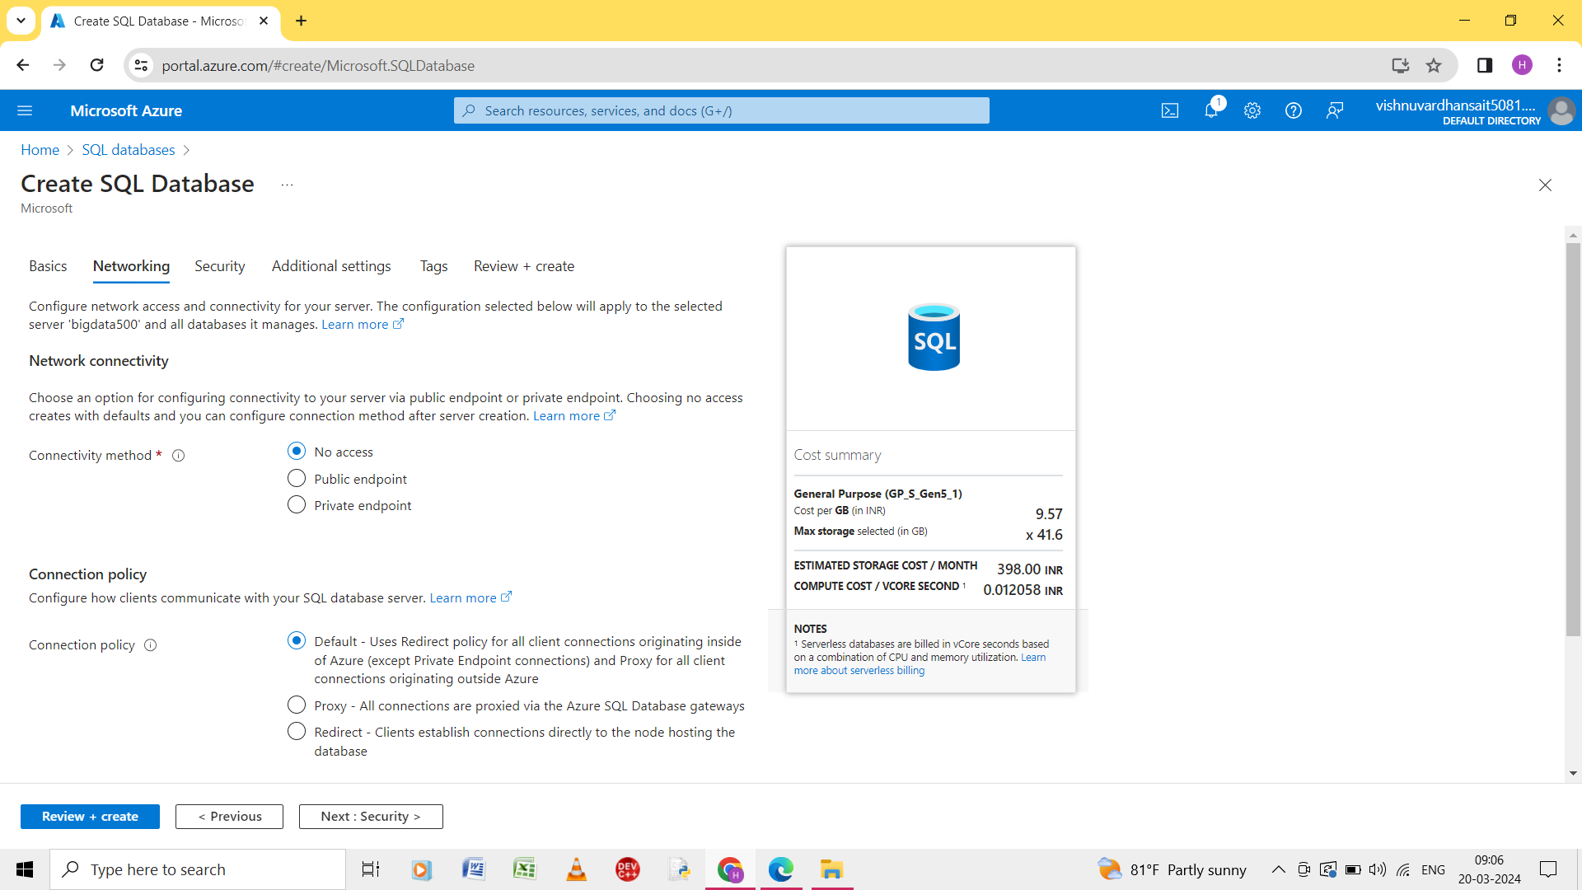

Step 2: enter the details of the networking .

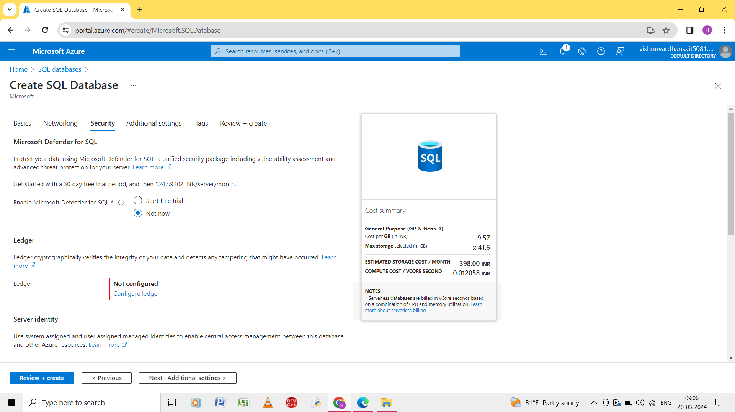

Step 3: enter the details of the security.

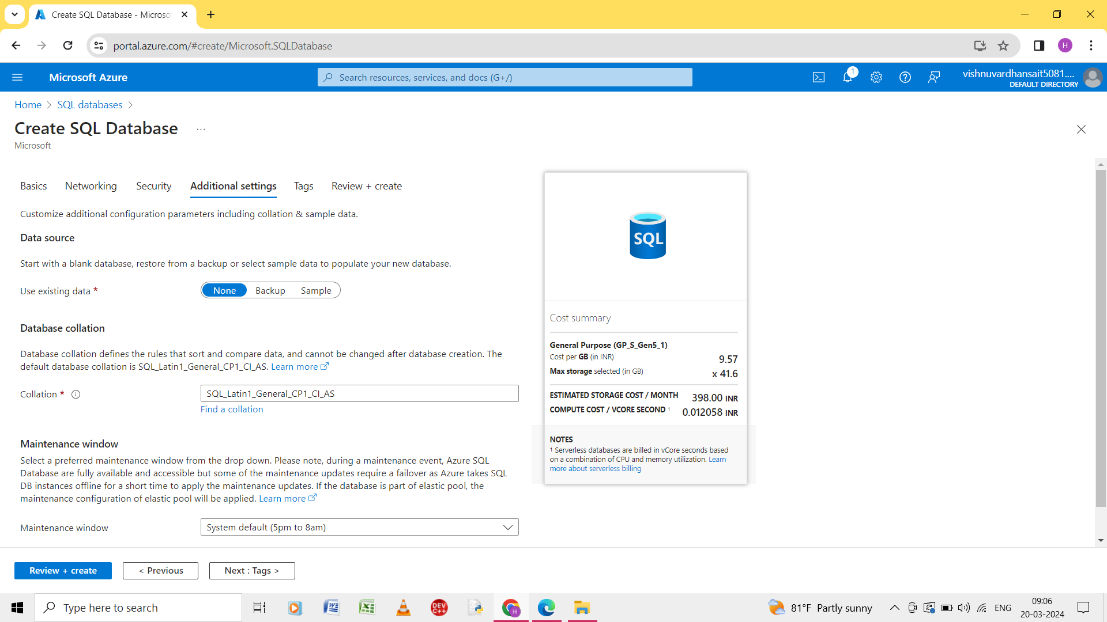

Step 4: enter the details of the Additional settings.

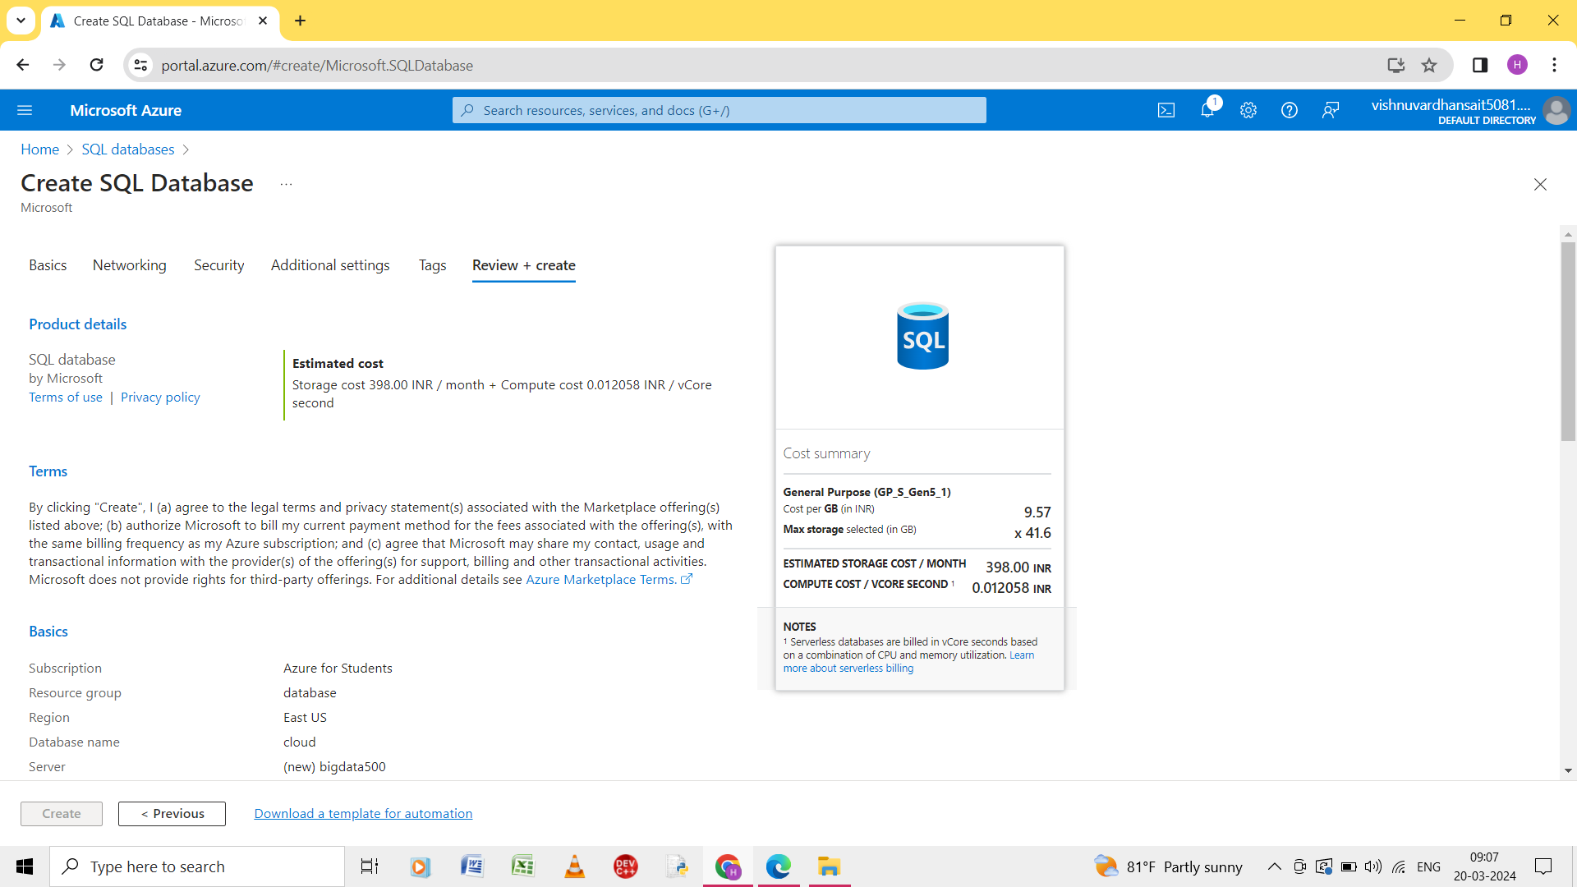

Step 5: click on the review and create and validation is passed.